ROYAL ROAD ELEMENTARY SCHOOL
Classroom Materials for Grade 1 French Immersion, 2022-2023
(When we request brands, it is because of quality.)
- 2 packages (12) sharpened pencils (Staedtler brand if possible — they last longer)
- 3 erasers (white)
- 3 Glue sticks (large size)
- 1 White Elmer's school glue
- 1 Package Crayola crayons (24)
- 1 Package Crayola pencil crayons (24)
- 1 Pack Crayola markers (no fine tips)
- 2 Hilroy Exercise books — pages are plain at the top and lined on the bottom (Yellow, 72 pages, 23.1cm x 18cm) *See picture below.
- 2 - 32pg Hilroy notebooks
- duotangs ( 2 blue, 2 orange, 2 green, 1 red)
- 2 Packages of 4 dry-erase markers (not Dollarama brand)
- 1 twin pocket duotang * See picture below.
- 1 scrapbook (Dollarama)
- 1 box Large Ziploc bags
- 1 box of sandwich bags
- 1 Pack heavy-duty plastic sleeves
- Scissors — good quality (steel blade; not Crayola)
- 1 message bag- Dollarama (Neoprene laptop ones last longer, see picture)
- 2 containers of modelling clay (ex: Play Doh)
- 2 Boxes of Kleenex
- Lunch bag
- Refillable water bottle
- Indoor sneakers (laces only if they can tie)
- "Roomy" book bag (it needs to hold snow pants, lunch bag, communication bag)
- Full change of clothing, labelled in a Ziploc bag.
$32 School fee (Can be paid in School Cash Online or by sending cash or cheque payable to
Royal Road School).
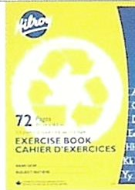
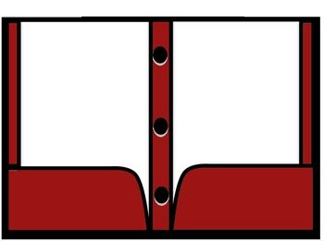
Please label and place all school supplies in plastic bag with your child's name on it.

